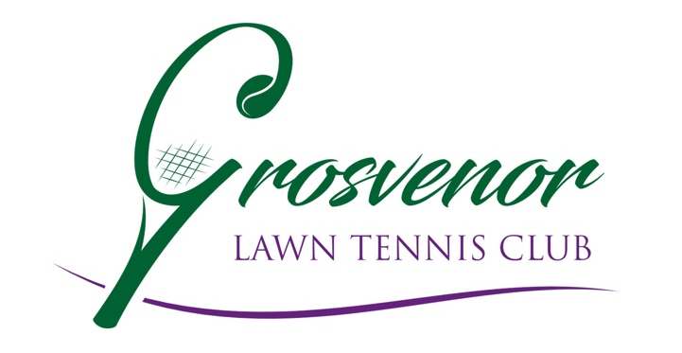
Code of Conduct

All members agree to:
· Prioritise the well-being of all children and adults at risk at all times
· Treat all children and adults at risk fairly and with respect
· Be a positive role model. Act with integrity, even when no one is looking
· Help to create a safe and inclusive environment both on and off court
· Not allow any rough or dangerous behaviour, bullying or the use of bad or inappropriate language
· Report all allegations of abuse or poor practice to the club Welfare Officer
· Not use any sanctions that humiliate or harm a child or adult at risk
· Value and celebrate diversity and make all reasonable efforts to meet individual needs
· Keep clear boundaries between professional and personal life, including on social media
· Have the relevant consent from parents/carers, children and adults before taking or using photos and videos
· Refrain from making physical contact with children or adults unless it is necessary as part of an emergency or congratulatory (e.g. handshake / high five)
· Refrain from smoking and consuming alcohol during club activities or coaching sessions
· Ensure roles and responsibilities are clearly outlined and everyone has the required information and training
· Avoid being alone with a child or adult at risk unless there are exceptional circumstances
· Refrain from transporting children or adults at risk, unless this is required as part of a club activity (e.g. away match) and there is another adult in the vehicle
· Not abuse, neglect, harm or discriminate against anyone; or act in a way that may be interpreted as such
· Not have a relationship with anyone under 18 for whom they are coaching or responsible for
· Not to have a relationship with anyone over 18 whilst continuing to coach or be responsible for them
All children agree to:
· Be friendly, supportive and welcoming to other children and adults
· Play fairly and honestly
· Respect club staff, volunteers and Officials and accept their decisions
· Behave, respect and listen to your coach
· Take care of your equipment and club property
· Respect the rights, dignity and worth of all participants regardless of age, gender, ability, race, culture, religion or sexual identity
· Not use bad, inappropriate or racist language, including on social media
· Not bully, intimidate or harass anyone, including on social media
· Not smoke, drink alcohol or drugs of any kind on club premises or whilst representing the club at competitions or events
· Talk to the club Welfare Officer about any concerns or worries they have about themselves or others
All parents agree to:
· Positively reinforce your child and show an interest in their tennis
· Use appropriate language at all times
· Be realistic and supportive
· Never ridicule or admonish a child for making a mistake or losing a match
· Treat all children, adults, volunteers, coaches, officials and members of staff with respect
· Behave responsibly at the venue; do not embarrass your child
· Accept the official’s decisions and do not go on court or interfere with matches
· Encourage your child to play by the rules, and teach them that they can only do their best
· Deliver and collect your child punctually from the venue
· Ensure your child has appropriate clothing for the weather conditions
· Ensure that your child understands their code of conduct
· Adhere to your venue’s safeguarding policy, diversity and inclusion policy, rules and regulations
· Provide emergency contact details and any relevant information about your child including medical history

Date Adopted: June 2026
Review Date: February 2027

